# CHAPTER 1

## INTRODUCTION

The Online Bus Ticket Booking System is a user-centric, technology-driven approach to reserving bus tickets. It leverages the power of the internet to bring ease and convenience to travelers, enabling them to plan their journeys with just a few clicks. This system not only caters to the needs of individual passengers but also serves bus operators and travel agencies by streamlining their ticket management and reservation processes.

Key components of this system include an extensive database of bus routes, schedules, and operators, real-time availability updates, secure payment processing, and electronic ticket generation. It eliminates the hassle of standing in long queues or making phone calls to book tickets, making the entire process efficient and accessible from the comfort of one's own device.

With the Online Bus Ticket Booking System, passengers can search for their desired routes, check available schedules, select seating preferences, and make secure payments through various payment methods. The system also offers a range of additional features, such as account management, booking history, and the ability to track buses in real time.

This introduction highlights the significance of the Online Bus Ticket Booking System in modernizing the travel industry and enhancing the convenience and accessibility of booking bus tickets. As we delve deeper into its functionalities and benefits, we will discover how this system has transformed the way people plan and secure their bus journeys, making it a valuable addition to the travel landscape.

### Key Features:

* + 1. **User-Friendly Interface:** The system boasts an intuitive and user-friendly interface developed with HTML and CSS, ensuring a seamless experience for Online Bus Ticket Booking.
    2. **Dynamic Data Handling with PHP:** PHP, a powerful server-side scripting language, is employed for robust data handling. It facilitates the creation of dynamic web pages, enabling real-time updates, and efficient communication. An Online Bus Ticket Booking System serves as the cornerstone for maintaining and enhancing relationships with graduates, providing a centralized platform for networking, information exchange, and collaboration.
    3. **Comprehensive Ticket Booking Profiles:**  can create and manage personalized profiles with details such as education history, professional achievements, and contact information. This ensures a comprehensive database that can be leveraged for various purposes.
    4. **Networking and Collaboration:** The system incorporates social networking features, allowing Booking to connect with each other based on common interests, professions, or geographic locations. Discussion forums and group creation further foster collaboration and knowledge exchange.
    5. **Event Management:** Organizing reunions, webinars, and other events becomes effortless with the integrated event management system. can RSVP, view event details, and interact with fellow attendees, fostering a sense of community.
    6. **Job Board and Career Services:** A dedicated job board assists alumni in their professional journeys. Employers can post job opportunities, and booking can explore career-related resources and mentorship programs.

Welcome to our Online Bus Ticket Booking – a dynamic platform designed to strengthen the bond between our prestigious institution and its accomplished ticket booking. This system is a testament to our commitment to fostering lifelong connections and facilitating collaboration among our graduates.

Creating an ticket Booking is a great way to maintain a strong connection between your institution and its graduates. This system can help you keep track of alumni information, organize events, and foster a sense of community among former students.

In this introduction, I'll provide a brief overview of the key features and technologies used in developing an Ticket Booking using PHP, HTML, and JavaScript.

The Ticket Booking is an important asset that any university may have. Ticket Booking are the persons who represent the university to the outside world The Ticket Booking webpage is designed for students who have graduated from the university. This is a website that allows former students to take advantage of the perks and services that a school provides after they graduate. Because of their huge potential, the Ticket Booking network is becoming increasingly significant in the development of the institution, benefiting both the school and the students. There are numerous advantages to being an Ticket Booking member of a college or institution.

Online Bus Ticket Booking has been designed using PHP-MySQL where in many user- friendly form controls have been added in order to make it a user interactive application. The project which stores Ticket Booking database which makes easier to maintain the records of the Ticket Booking along with details.There are many records such as Ticket Booking details, upcoming event details etc., Handling all the records is a difficult task for the user this product provides easy way for maintaining records. Alumni of a college generally stay in touch with their immediate friends but find it hard to stay connected with other college mates. Contact between Ticket Booking can be used to forge business connections and to gain references or insight in a new field.

Ticket Booking work can consist of alumni mentoring students, organizing alumni days, having training sessions during alumni days for Ticket Booking inviting to give lectures, arranging work practices, and proposing topics of theses, raise funds for the organizations. It is important to carry out a good follow-up marketing of Ticket Booking .

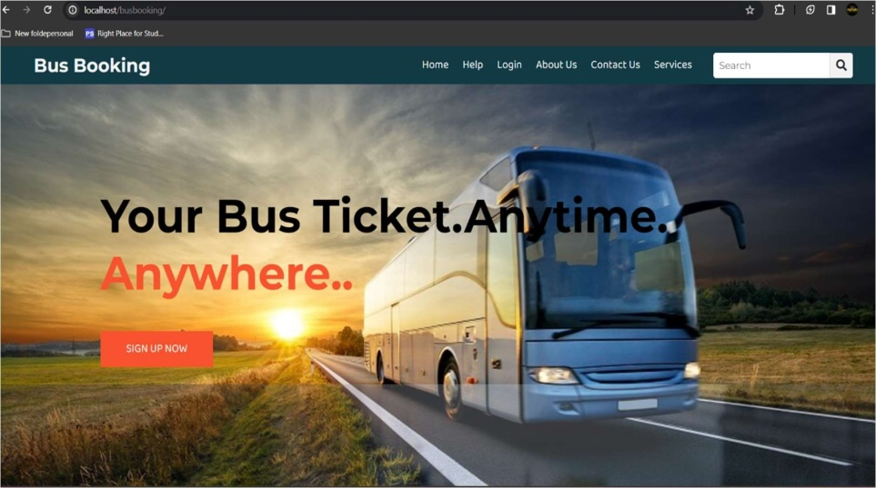

**Fig 1.1 Online Bus Ticket Booking**

# CHAPTER 2

## PROBLEM STATEMENT

The traditional methods of booking bus tickets through physical counters or phone reservations have become increasingly inconvenient and inefficient in today's fast-paced world. To address these issues and enhance the overall travel experience, there is a pressing need for the development and implementation of an Online Bus Ticket Booking System. The development of an Online Bus Ticket Booking System aims to address these challenges by providing a user-friendly, efficient, and secure platform for passengers to book their bus tickets, access real-time information, and select their preferred seating arrangements. Furthermore, it seeks to enhance the operations of bus operators and contribute to a more sustainable and accessible transportation ecosystem

There are now more than one million unemployed, so the technology willbe integrated into a database on a website so that information can be accessed in a flexible and easy way.

### Problem statement

* + 1. **Manual system**

The existing system is a manual system but all the records are kept on an excel sheets, which are time consuming process. This is neither a completely computerize system nor manual system. In such type of system, to keep the information of a student about their starting year will be a hectic task. Moreover, excel sheets cannot be spread easily.

If a user wants any record, then they have to find that record from all records which a time-consuming process. Similarly Editing and maintenance a particular Bus Ticket Booking record or a class is a difficult and require much time.

Our objective is to provide a web based computerized Bus Ticket Booking that will be fast and easy to access from anywhere and data will be stored on database and MySQL language will be used to access and manipulate data. This system will provide online storage to keep the information of Bus Ticket Booking.

### Job Opportunities

The existing system does not provide job opportunities for Bus Ticket Booking The use of an Bus Ticket Booking is one of the many valuable resources available to graduates. Job searchers can connect with essential tools and services through an Bus Ticket Booking, which can help them, establish a more effective job search outcome.

Our web-based alumni system will provide job opportunity features so that when the alumni graduates and join our system by providing their details such as name, phone number, qualification, address etc. they can search for their related job opportunities that will help them to grow.

In the existing system there is no active committee in the Bus Ticket Booking that will keep the check and balance of Bus Ticket Booking.

### Search document

As there is not central database for storing information of Bus Ticket Booking and as data is store in individual file format then there are more chances of losing data as there are no solid backup and there are more chances of security violation of data as anyone who have access to computer room can violate data of any Bus Ticket Booking.

And is case of any natural disaster or damage of computer in which the data is store, Due to no backup the information may be lose for forever.

Our system will be secure as it is based on database storage rather than excel sheets so it will be more secure because no one can get access to data until it is authorized user and user have to sign in with its login credentials such as ID and password.

### Lack of Interaction

In previous system, there is no chat feature. There is not specific way for old Bus Ticket Booking to communicate with their old fellows and friends. Mostly Alumni like to come back and see if their records are keep standing. They communicate with their friends and ask about record updating. So, Communication gap is a big problem in previous Bus Ticket Booking systems.

# CHAPTER 3

**MOTIVATION OF STUDY**

The motivation behind developing an Bus Ticket Booking using PHP, HTML, and JavaScript can be attributed to several key factors, each contributing to the enhancement of the overall alumni experience and the efficiency of Bus Ticket Booking-related activities. Here are some potential motivations for such a study:

### Enhanced Bus Ticket Booking:

An Bus Ticket Booking provides a platform for better communication and engagement between the Bus Ticket Booking and the Traveling. It can include features such as discussion forums, event notifications, and updates, fostering a sense of community among Bus Ticket Booking.

### Network Building:

Creating a comprehensive Bus Ticket Booking directory within the system can facilitate networking opportunities. Bus Ticket Booking can connect with each other based on their fields of expertise, industry, or geographical location, thus fostering professional collaborations and mentorship.

### Effective Communication:

A centralized system allows for efficient communication between the institution and its Bus Ticket Booking. Important announcements, newsletters, and event invitations can be easily disseminated, keeping the Bus Ticket Booking informed about the latest developments at their alma mater.

### Event Management:

Bus Ticket Booking often include event management features, making it easier to organize reunions, conferences, and other gatherings. This can help in bringing Bus Ticket Booking together, strengthening ties, and providing opportunities for continued learning and professional development.

### Donation and Fundraising:

The system can serve as a platform for fundraising and accepting donations from Bus Ticket Booking It can showcase ongoing projects, campaigns, and initiatives that Bus Ticket Booking can contribute to, thereby supporting the institution's growth and development.

### Tracking Alumni Achievements:

The system can be designed to track and showcase the achievements of alumni in their respective fields. This not only celebrates alumni success but also serves as inspiration for current students.

### Data Management and Analytics:

An alumni management system helps in maintaining accurate and up-to-date records of alumni. This data can be used for generating insights and analytics, aiding the institution in making informed decisions related to alumni relations and engagement strategies.

### Career Services:

The system can include features related to career services, providing a platform for alumni to offer job opportunities, internships, and mentorship to current students. This strengthens the bridge between academia and the professional world.

* 1. **Architecture Diagram**

# CHAPTER 4



Home Page

Sign Up

Login page

Fill

Registration Details

Insert

Register Details info

Database

Admin Details

User Login

Admin Login

User

Profile

User

Tickets

Ticket

Booking

Bus

Details

Enter

Passenger

Details

Bus

Manage

Payment

Details

Routes

Transaction

Payment

Conformation

Received

Logout

## DETAILS OF THE DESIGN

**Fig 4.1 system architecture diagram**

An entity relationship diagram (ERD) shows the relationships of entity sets stored in a database. An entity in this context is an object, a component of data. An entity set is a collection of similar entities. These entities can have attributes that define its properties.

There are two reasons to create a database diagram. You’re either designing a new schema or you need to document our existing structure.

If you have an existing database you need to document, you create a database diagram using data directly from your database. You can export your data base structure as a CSV file (there are some scripts on how to do this here), then have a program generate the ERD automatically.

An ER diagram is a means of visualizing how the information a system produces is related. There are five main components of an ERD:

* Entities, which are represented by rectangles. An entity is an object or concept about which you want to store information.
* A weak entity is an entity that must defined by a foreign key relationship with another entity as it cannot be uniquely identified by its own attributes alone.
* Actions, which are represented by diamond shapes, show how two entities share information in the database.
* In some case, entities can be self-linked. For example, employees can supervise other employees.
* Attributes, which are represented by ovals. A key attribute is the unique, distinguishing characteristic of the entity.
* A multivalued attribute can have more than one vale. For example, an employee entity can have multiple skill values.
* A derived attribute is based on another attribute. For example, an employee’s monthly salary is based on the employee’s annual salary.
* Connecting lines, solid lines that connect attributes to show the relationships of the entities in diagram.
* Cardinality specifies how many instances of an entity relate to one instance of another entity. Ordinality is also closely linked to cardinalit.
  1. **Design**

### Home Page

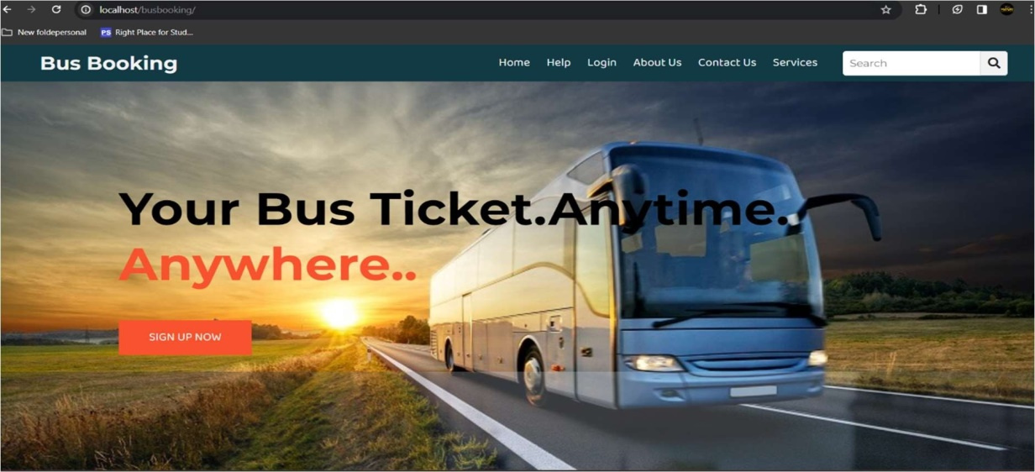

**4.2.2 HelpPage**

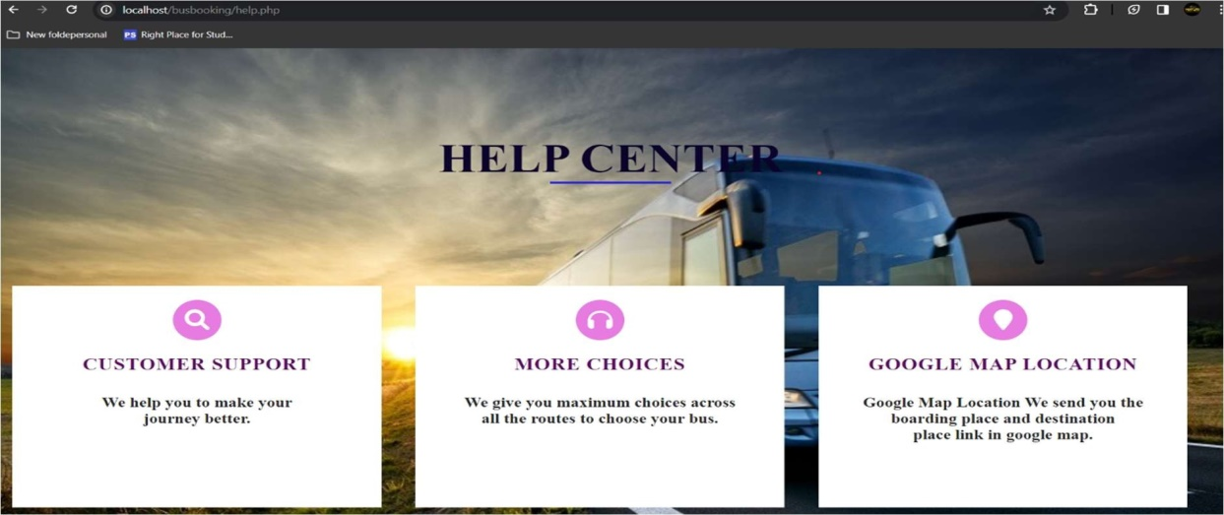

**4.2.3 Registration Page**

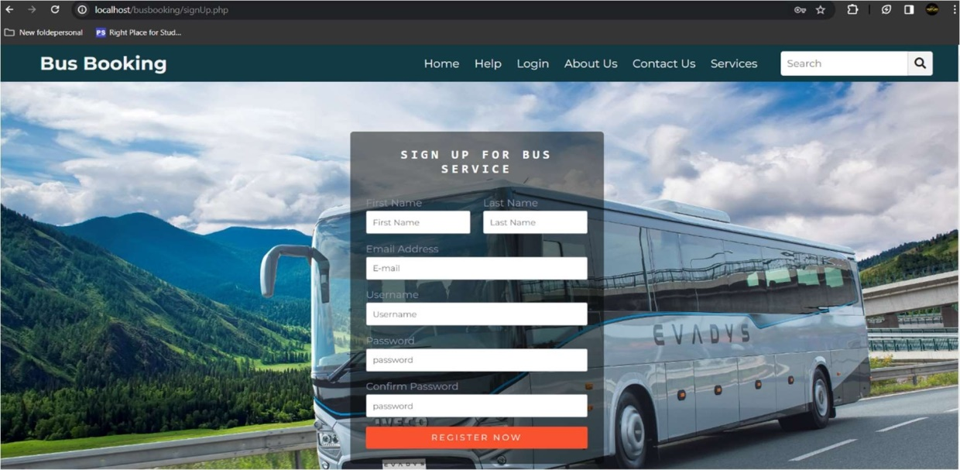

**4.2.4 Login Page**

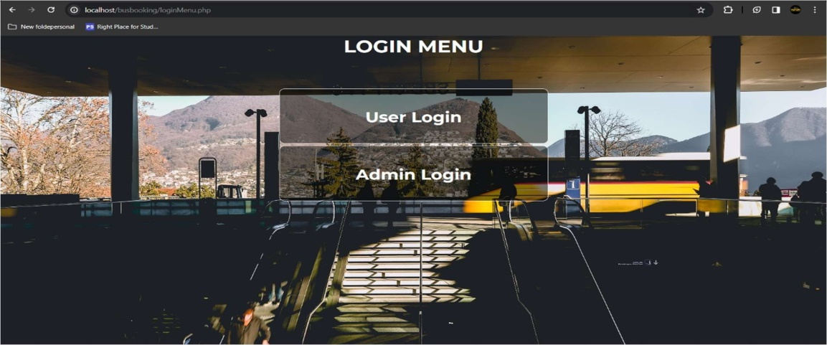

**4.2.5 User Page**

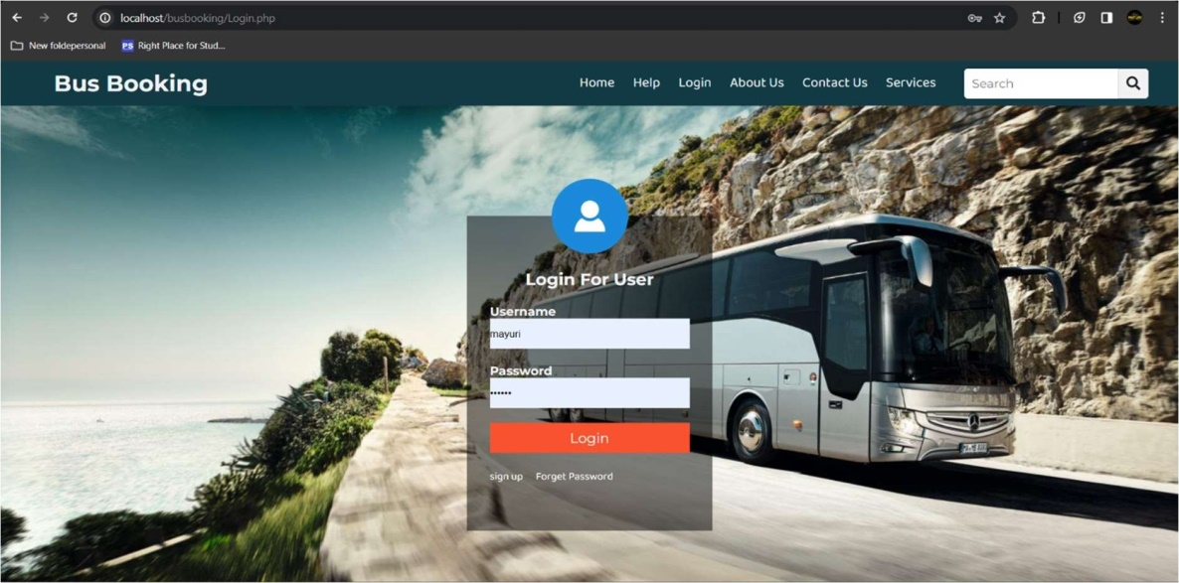

**4.2.6 User Pannel**

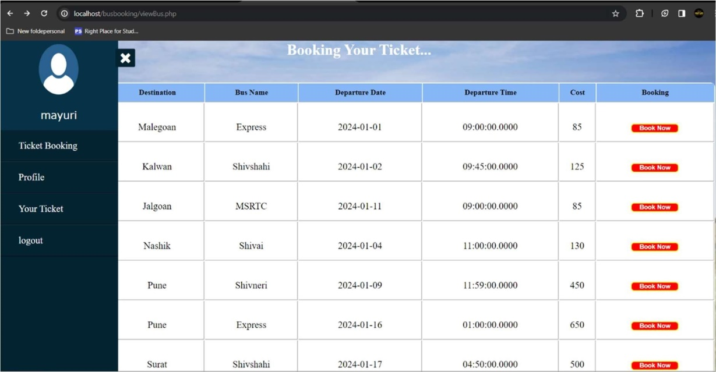

**4.2.7 UserProfile**

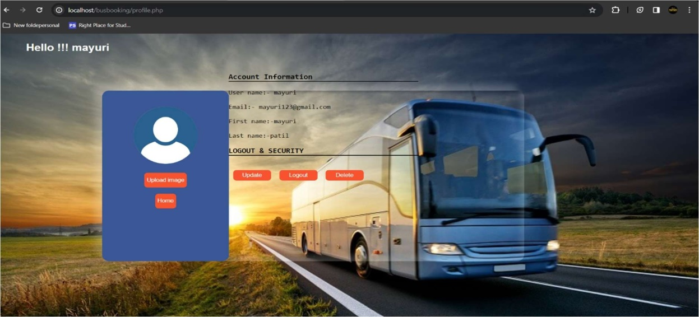

**4.2.8 User Booking Details**

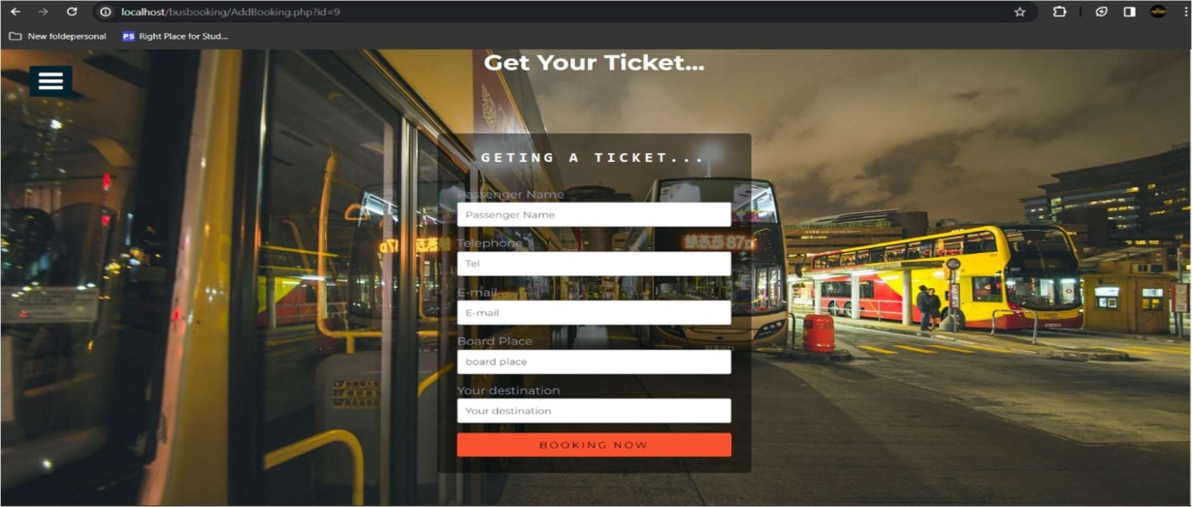

**4.2.9 User Payment Details**

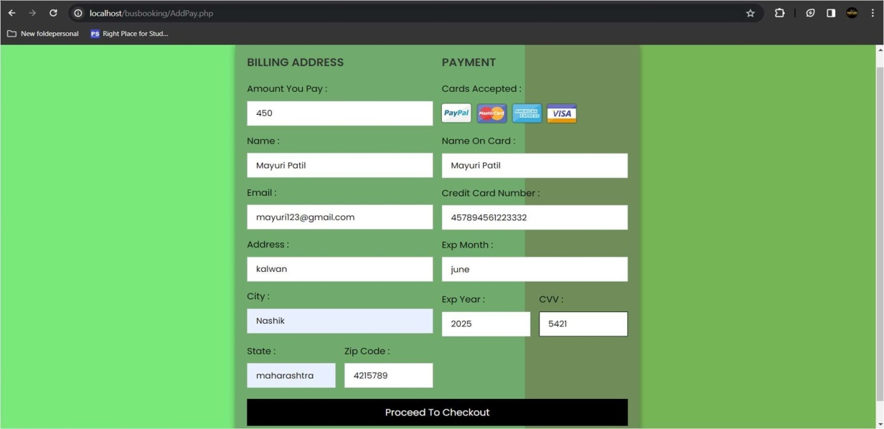

**4.2.10 User Payment Confermation**

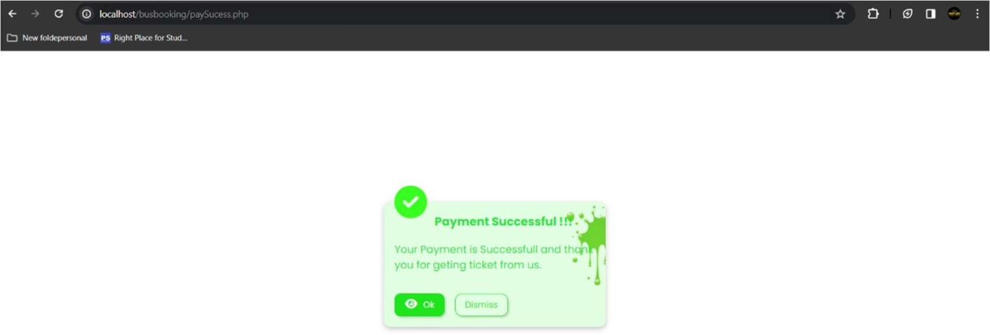

**4.2.11. Admin login**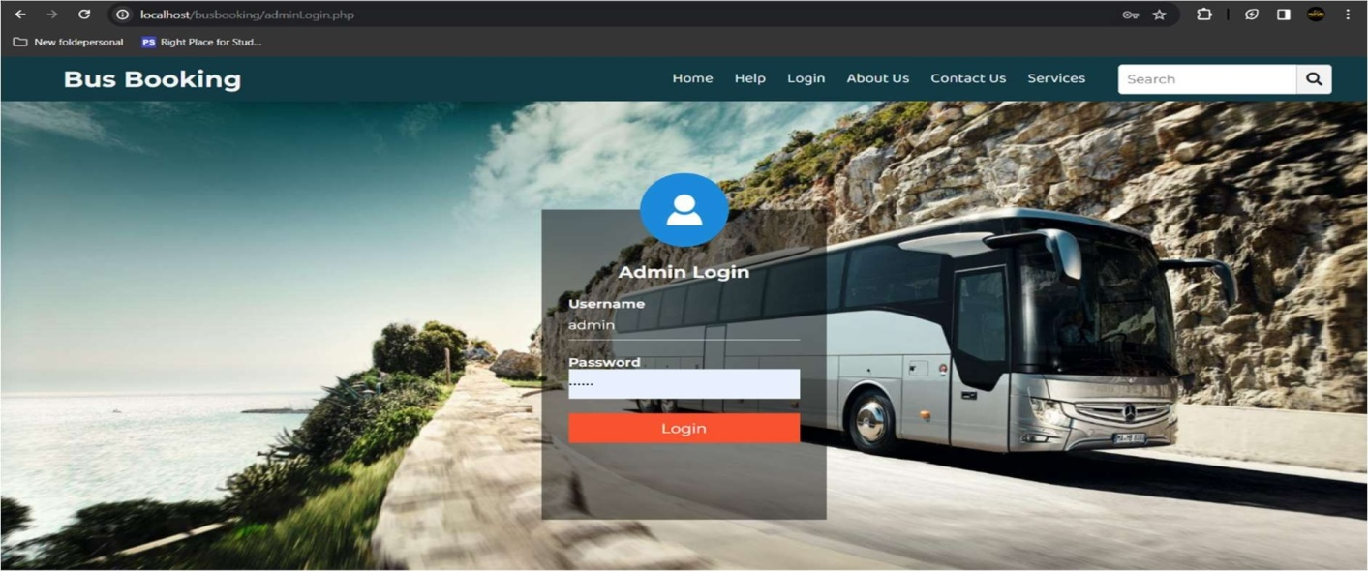

**4.2.12 Admin Manage Routes**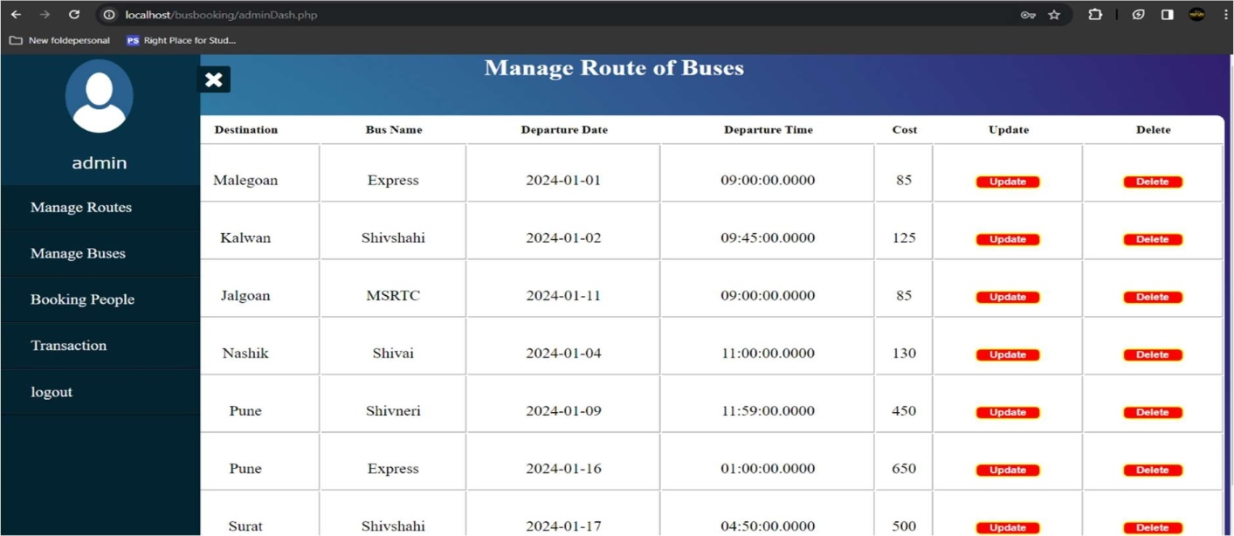

### Diagrams

* + 1. **Use Case Diagram for Admin**

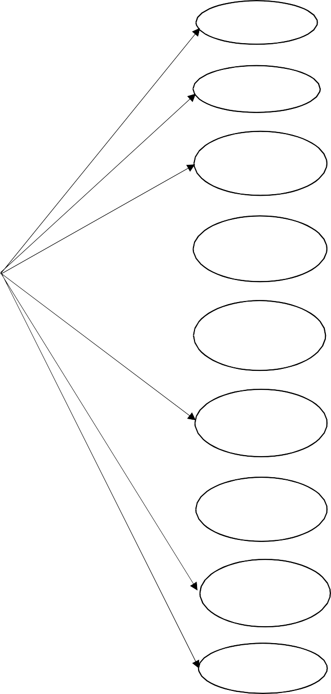

Login

Profile

Book Reservation

Manage Bus

User

Admin

Manage Route

User Ticket

Transition Receive

Confirm

Booking

**Fig 4.3.1 Admin**

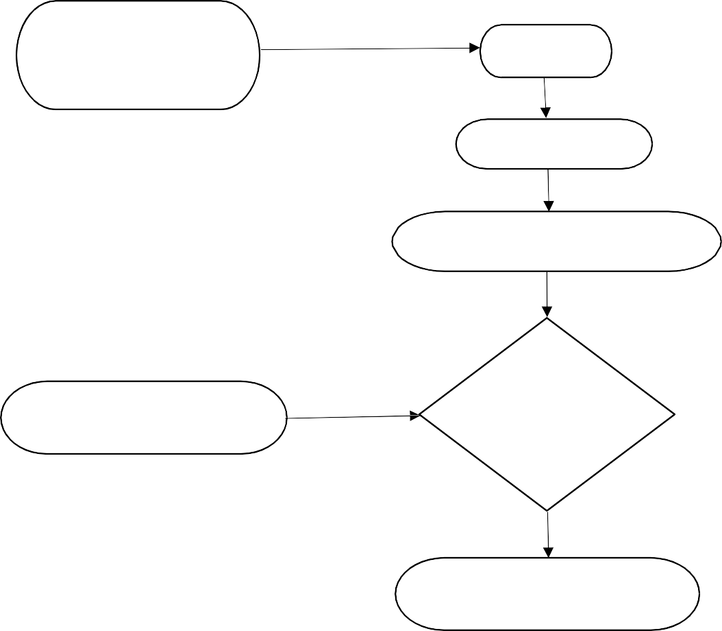

Admin is

Start

Register

Login

Insert User ID and Password

Invalid Login/Password

Check login

ID and Password

Login into Admin Pannel

**4.3.2 ACTIVITY DIAGRAM FOR ADMIN**

**4.3.3 ACTIVITY DIAGRAM FOR USER**

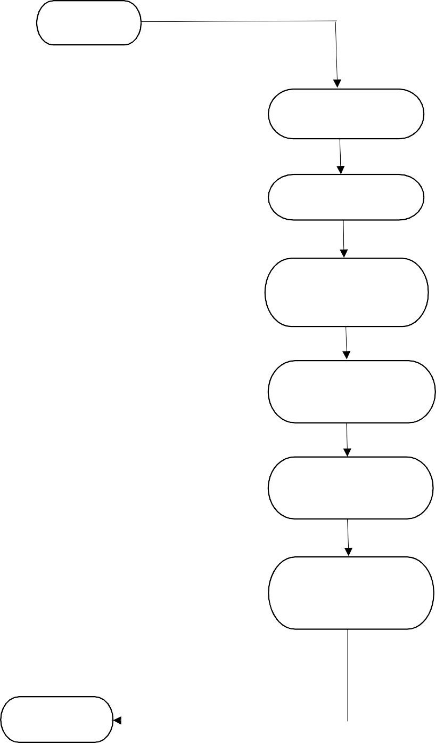

User

Select Route

Select Bus

Make Reservation

Passenger Details

Make Payment

Payment

Logout

### ER Diagram

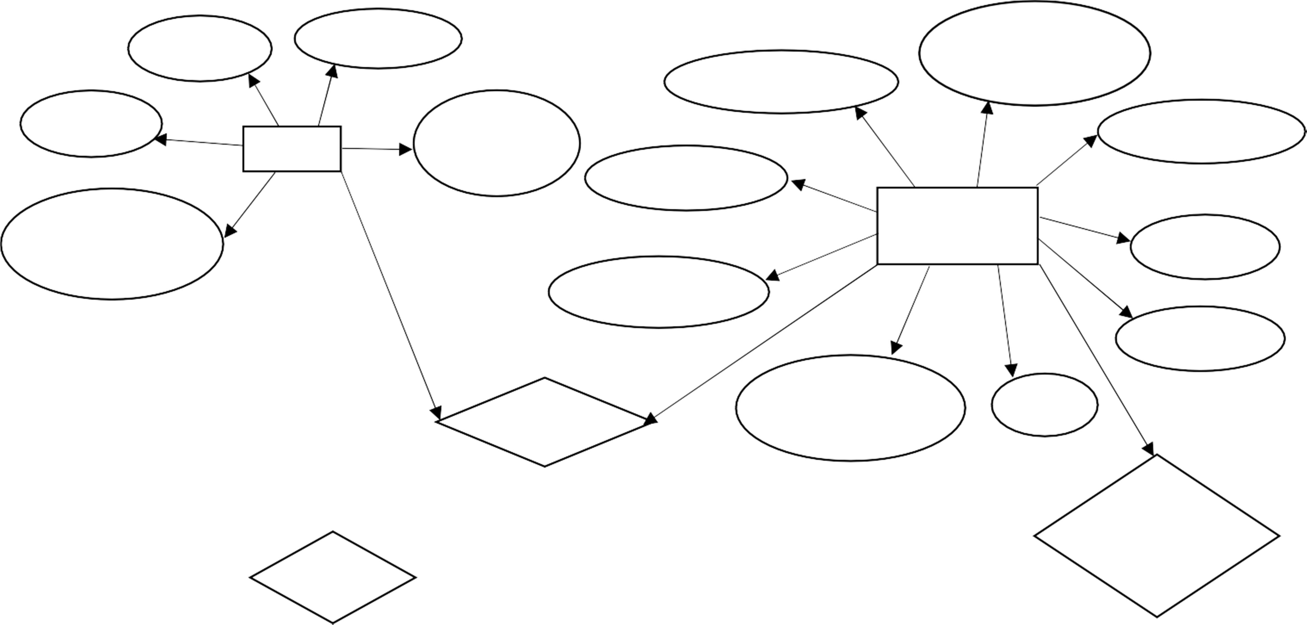

NameContact DepartmentTime

Bus Number

Email

User Board palce Ticket

Bus name

Your Bus Info

Destination Source

Destination

Booking

DepartmentName Id

Board

Travel

Through

Buy

Id Boarding

Ticket Route id

Price Route

Passenger

Destination

Destination Source

**CHAPTER 5**

## METHODOLOGY USED

### HTML

The Hypertext Markup Language, or HTML is the standard markup language for documents designed to be displayed in a web browser. It can be assisted by technologies such as Cascading Style Sheets (CSS) and scripting languages such as JavaScript.

Web browsers receive HTML documents from a web server or from local storage and render the documents into multimedia web pages. HTML describes the structure of a web page semantically and originally included cues for the appearance of the document. HTML can embed programs written in a scripting language such as JavaScript, which affects the behaviour and content of web pages. Inclusion of CSS defines the look and layout of content. The World Wide Web Consortium (W3C), former maintainer of the HTML and current maintainer of the CSS standards, has encouraged the use of CSS over explicit presentational HTML since 1997.

### CSS

Cascading Style Sheets (CSS) is a style sheet language used for describing the presentation of a document written in a markup language such as HTML. CSS is a cornerstone technology of the World Wide Web, alongside HTML and JavaScript.

CSS is designed to enable the separation of presentation and content, including layout, colours, and fonts. This separation can improve content accessibility; provide more flexibility and control in the specification of presentation characteristics;

Enable multiple web pages to share formatting by specifying the relevant CSS in a separate .css file, which reduces complexity and repetition in the structural content; and enable the .css file to be cached to improve the page load speed between the pages that share the file and its formatting.

### JavaScript

JavaScript is used by programmers across the world to create dynamic and interactive web content like applications and browsers. JavaScript is so popular that it's the most used programming language in the world, used as a client-side programming language by 97.0% of all websites.

Client-side languages are those whose action takes place on the user's computer, rather than on the server. JavaScript is versatile enough to be used for a variety of different applications, like software, hardware controls, and servers.

JavaScript is most known for being a web-based language, because it's native to the web browser. The web browser can naturally understand the language, like how a native English speaker can naturally understand English.

### PHP

PHP is acronym for PHP: Hypertext Preprocessor. PHP is an “open source general purpose scripting language that is especially suited for web development and can be embedded into HTML” (The PHP Group, 2018). PHP is mainly used in dynamic web page, including CLI (command line interface) and GUI (graphical user interface) program.

It has the feature of good across-platforms and easy transplant (Lei, Ma and Tan, 2014).

PHP is not an object-oriented language like Java.

But according to Haydar (2007), PHP 5 implements almost complete object-oriented features. 83.1% of all the websites use PHP as server-side programming language and 14.1 of all websites use ASP.NET as server-side language by January 2018 (W3Techs, 2018).

### MySQL

MySQL is an open-source relational database management system (RDBMS). Its name is a combination of "My", the name of co-founder Michael Widenius's daughter, and "SQL", the abbreviation for Structured Query Language. A relational database organizes data into one or more data tables in which data types may be related to each other; these relations help structure the data.

SQL is a language programmers use to create, modify and extract data from the relational database, as well as control user access to the database. In addition to relational databases and SQL, an RDBMS like MySQL works with an operating system to implement a relational database in a computer's storage system, manages users, allows for network access and facilitates testing database integrity and creation of backups.

# CHAPTER 6

## RESULTS & INFERENCES

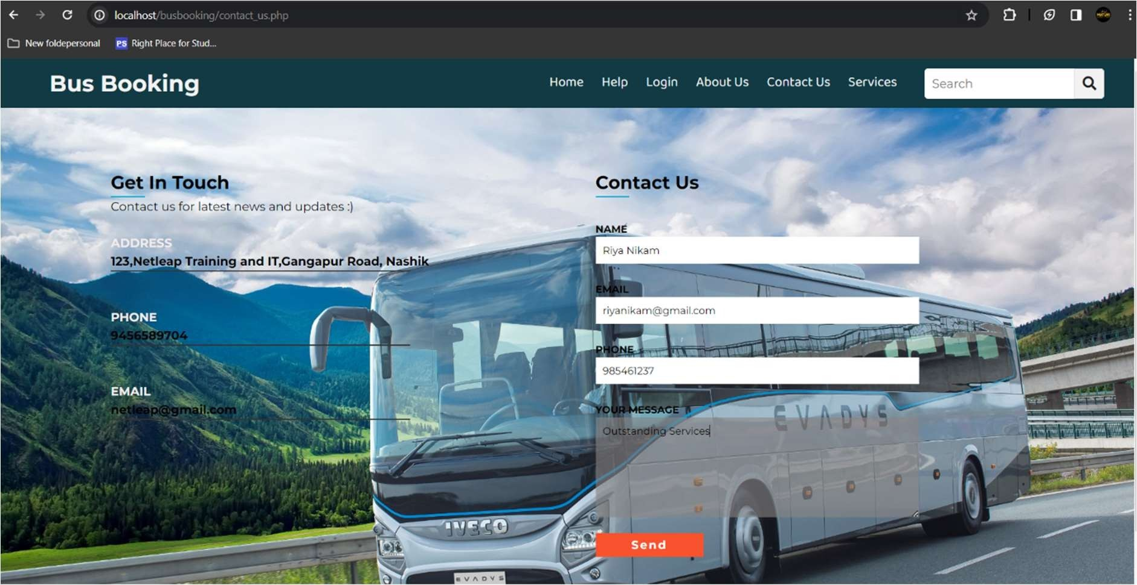

**Fig 6.1 Home Page**

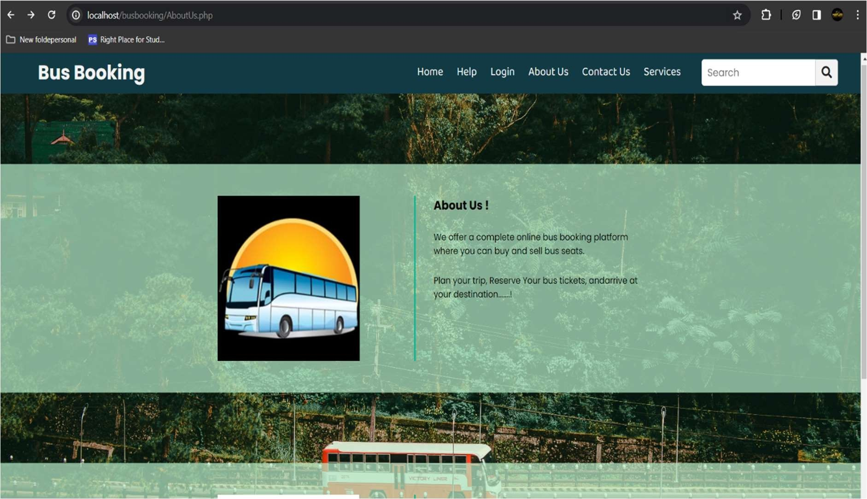

**Fig 6.2 About Us Page**

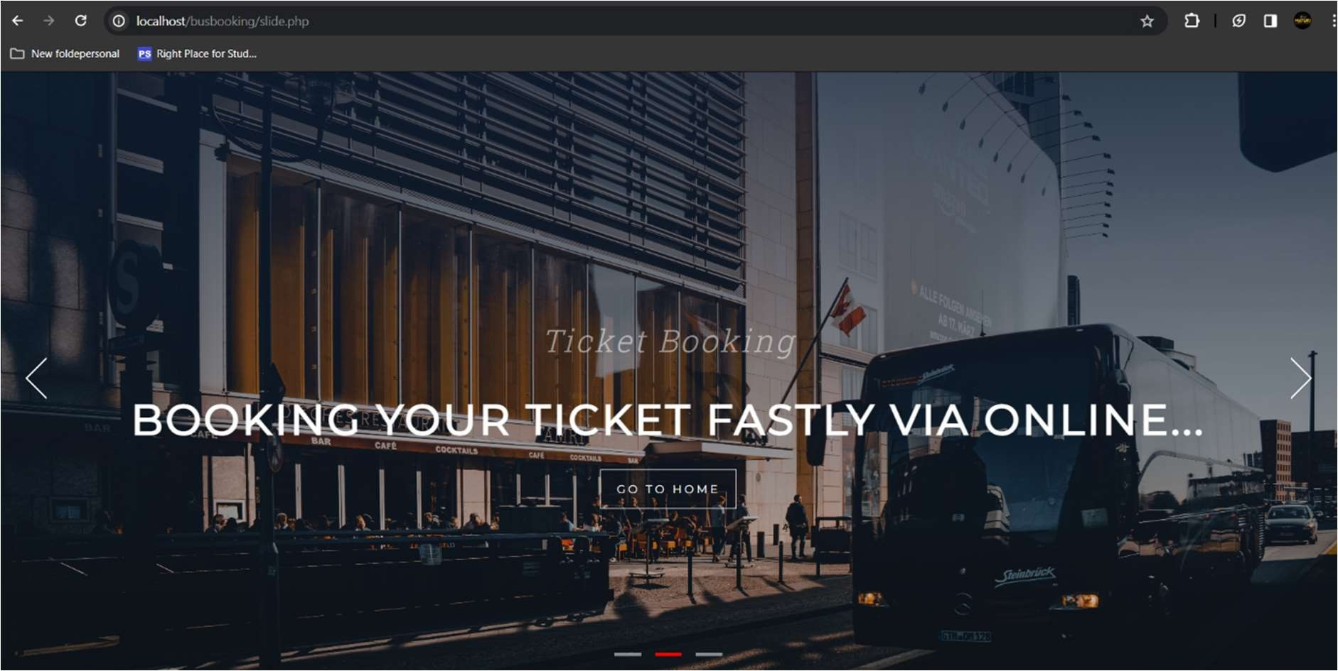

**Fig 6.3 Booking Page**

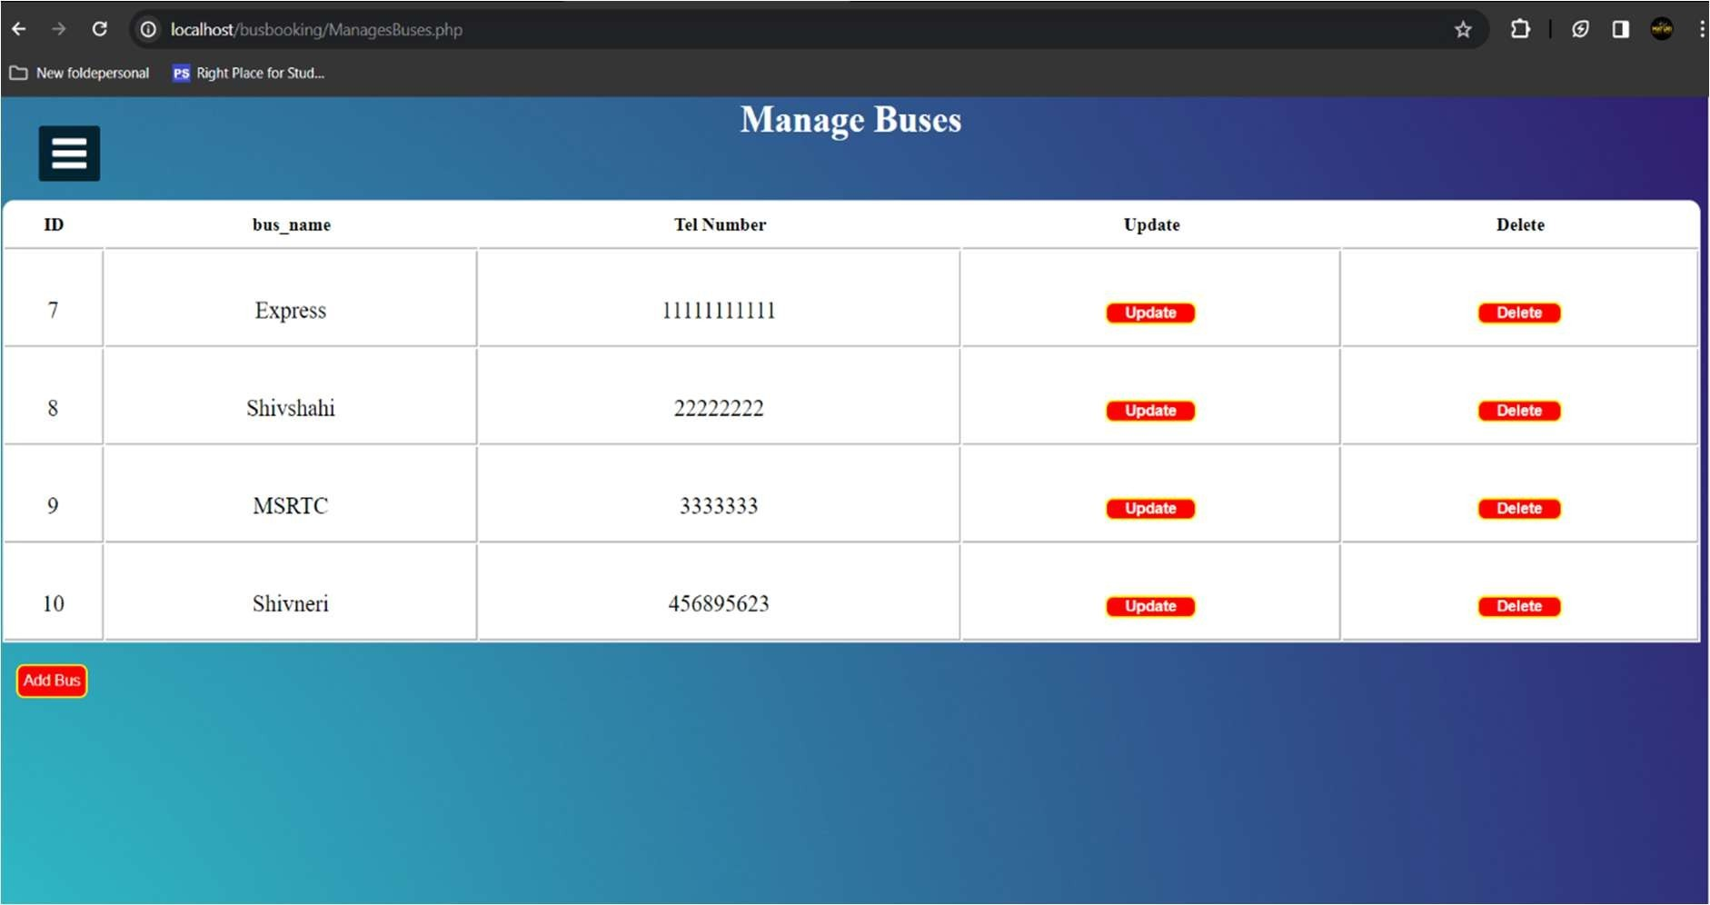

**Fig 6.4 Manage Booking Page**

# CHAPTER 7

**CONCLUSION**

In conclusion, the development and implementation of an Online Ticket Booking System represent a significant step forward in modernizing the travel and ticket reservation industry. This system offers a wide array of advantages for both passengers and service providers, catering to the ever-evolving needs of a digitalized world.

The convenience and accessibility provided by the online platform have redefined the way travelers plan and secure their tickets. The real-time information on routes, schedules, and seat availability empowers users to make informed decisions, enhancing the overall travel experience.

Overall, the Online Ticket Booking System represents a pivotal advancement in the way we plan, book, and experience travel. This digital transformation is set to continue to reshape the way we access and enjoy travel services, promising a more seamless and convenient journey for all.

**FUTURE SCOPE**

An Online Bus Ticket plays a crucial role in maintaining and fostering relationships between

an educational institution and its alumni. Here are some potential features and functionalities that

can enhance the scope and effectiveness of an Online Bus Ticket :

* The Bus Reservation System will improve the efficiency, convenience, and comfort of the reservation process.
* Customers can reserve the seats they want.
* They can see whether there are any open positions on a given date.
* Customers can search availability, reserve a ticket, or cancel a ticket 24 hours a day, seven days a week.
* You can access the online system at any time. The user is not required to visit an office

## REFERENCES

1. "Database System Concepts" by Abraham Silberschatz, Henry F. Korth, and S. Sudarshan.
2. "Software Engineering: A Practitioner's Approach" by Roger S. Pressman.
3. "Database Management Systems" by Raghu Ramakrishnan and Johannes Gehrke:
4. "Web Development with HTML, CSS, and JavaScript" by Jon Duckett:
5. "Clean Code: A Handbook of Agile Software Craftsmanship" by Robert C. Martin:
6. "Software Engineering: A Practitioner's Approach" by Roger S. Pressman:
7. "Information Architecture: For the Web and Beyond" by Louis Rosenfeld and Peter Morville:
8. [https://www2.dom.edu/sites/default/files/documents/about/oir/alumni](https://www2.dom.edu/sites/default/files/documents/about/OIR/alumni_data_enhancement_project_final_report_sept_12.pdf)
9. [_data_enhancement_project_final_report_sept_12.pdf](https://www2.dom.edu/sites/default/files/documents/about/OIR/alumni_data_enhancement_project_final_report_sept_12.pdf)
10. <http://1000projects.org/download-an-alumni-association-java-project-report.html>
11. <http://projectsgeek.com/2015/11/alumni-management-system-java-project.html>